On free software art, design, communities and committees.
Dave Griffiths
http://www.pawfal.org/dave

The power of free software is in the vibrancy and strength of its communities. These communities develop and nurture new ways of thinking and problem solving. The realm of free software is also highly politically charged - pressure can be put on people, including software artists, to embrace open source methods to the last letter. It needs to be recognised that the development of software for artistic practice has different needs and problems than the more widely understood realm of developing software as engineering solutions to specific problems.

Firstly it might be useful to discuss what software really is.

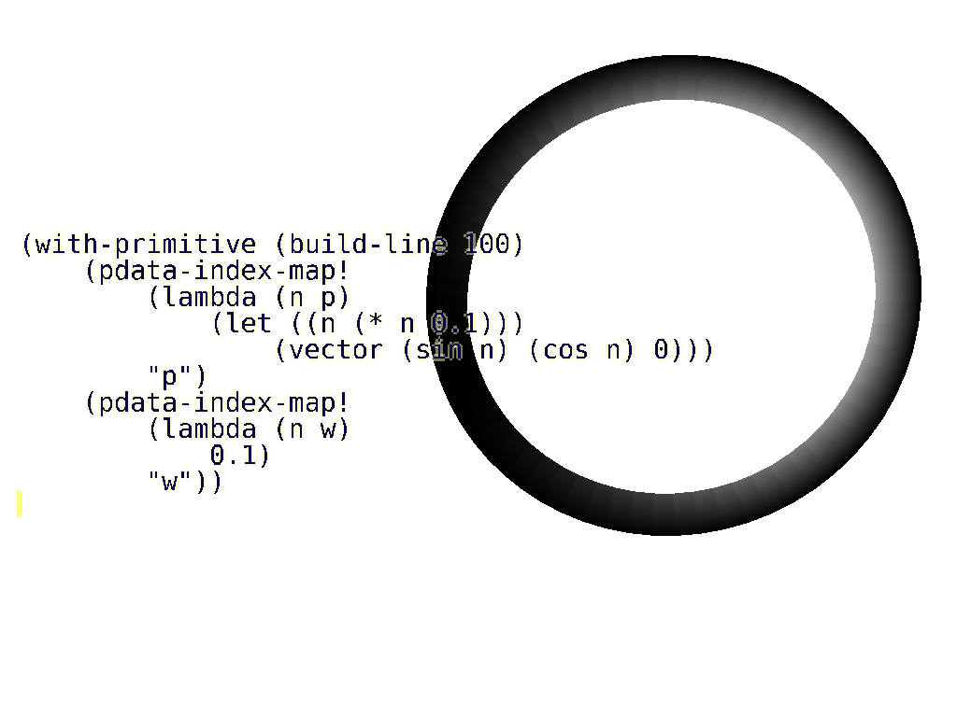
Software is people
The value in a piece of software is the group of people who are involved in it's design, construction, documentation and use. Good software forms a shared goal, and a shared way of working and communicating, so the community is of great importance to both those using and constructing a piece of software.

Software with a good community surrounding it is more useful than software which is engineered well, but lacks a community. Engineering alone is not enough to get most people's attention and continued interest, and doesn't guarantee people investing time learning and using it.

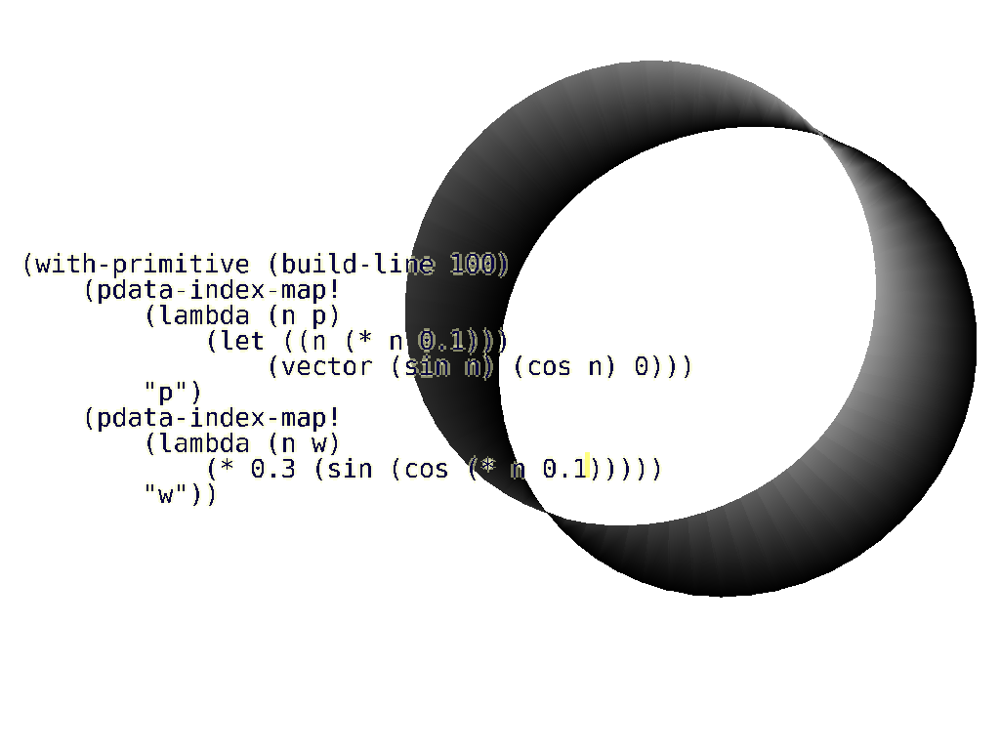
It's a mistake to separate the executable product from it's community when discussing software. The community dictates the future of a piece of software.

Software isn't source code
Source code represents a fixed point in time in a continuing succession of decisions which form the process of software development. Finished software is software which is not used any more.

The loss of the community surrounding some software can be more drastic than the loss of it's source code, as new people taking up the initiative will have to learn why decisions were taken with the design of the software. The source code can only tell you with certainty "what" decisions were taken. The "whys" are generally be found in comments and version control commit notes - but there is no compiler or interpreter to enforce this information, and it is generally inadequate to form a good understanding. The usual result of the loss of a group surrounding a piece of software, is starting again, which means rewriting, and retreading old ground; remaking the decisions. [1] In a commercial setting this is usually a very bad idea [2] as the extra effort is costly, and it doesn't get you any further in the long run.

One kind of free software is worth special mention: when source code is released to the wider community only once – and is not considered to be in the process of open development. Such projects are usually developed in a closed form, and are released when they have been completed, or when other development has come to a halt. Such 'single release' projects are a weaker form of free software, but are still very important as they can be learned from, experimented with, or in some cases picked up by new communities and turned into full open source developments. [3][4]

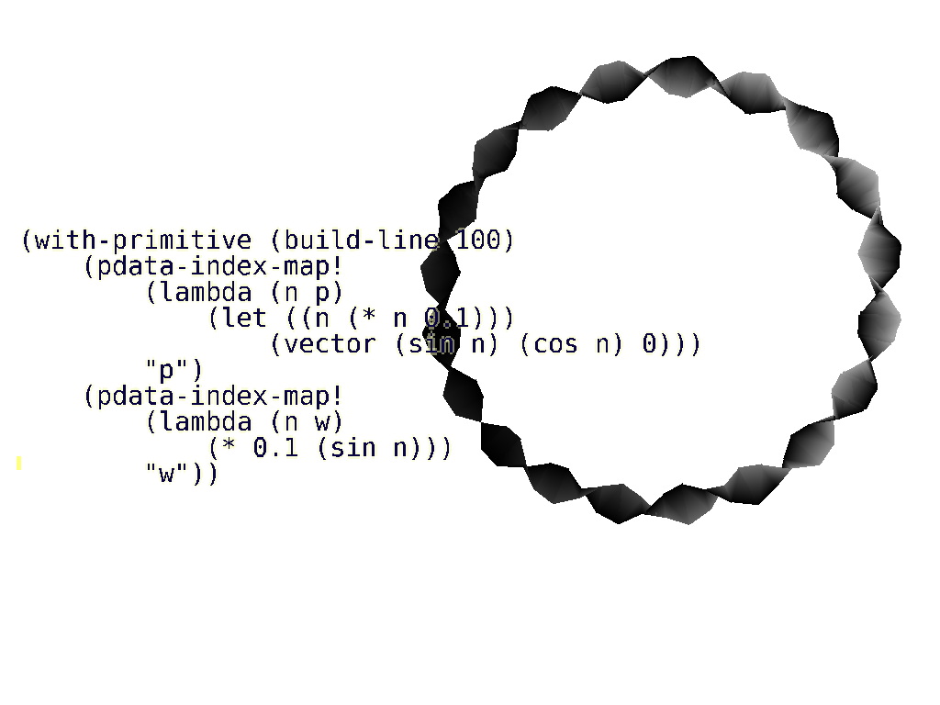
Three classes of software
We can break down software development into 3 broad categories based on the intent, or the nature of the goals it is designed to fulfil. These categories are gross simplifications, as most software is comprised of a mix of these types.

1. Classical 'tool' - Simple goals

The conventional idea of a piece of software is that of a tool for achieving some clear purpose. This is not a matter of software complexity – there may be many different competing uses, and a very complex implementation required. However, with this type of software, the uses are straightforward, even if there are many of them. Examples of classical tools range from the 'ls' command to a web server.

2. An environment for working in - Complex goals

When the nature of the goal is more complicated, and involves more human issues, software often ends up providing functionality through an environment. This is usually a text or graphical user interface. In software designed for artistic use, programs often have to go one step further, enriching their environment with a scripting interpreter [5-8] or a visual programming language [9-11]. These are needed because artistic goals are hard to predict, and the solutions need more flexibility to be useful in the long term. It is often surprising as a developer, how your users actually use software you have written in order to solve their problems. If your solutions are too prescriptive, you limit their abilities, but if you provide them with an environment they can reconfigure and extend, they will be happy for much longer.

3. Artistic - Ambiguous goals

A lot of software is written where goals are difficult to pin down at all. Someone may write a program in a playful way, to exercise the use of a new language or try out something new. The goals for game play code in computer games and software written to produce generative art are very difficult to define. Software art [12] is strongly ambiguous, as it comprises programs which are written to express something by merely existing. It's not even required that they run, or do anything at all. Sometimes software is the only way to express something. At other times the writing of software is an artistic process of exploration, such as sketching code [13] or livecoding [14].

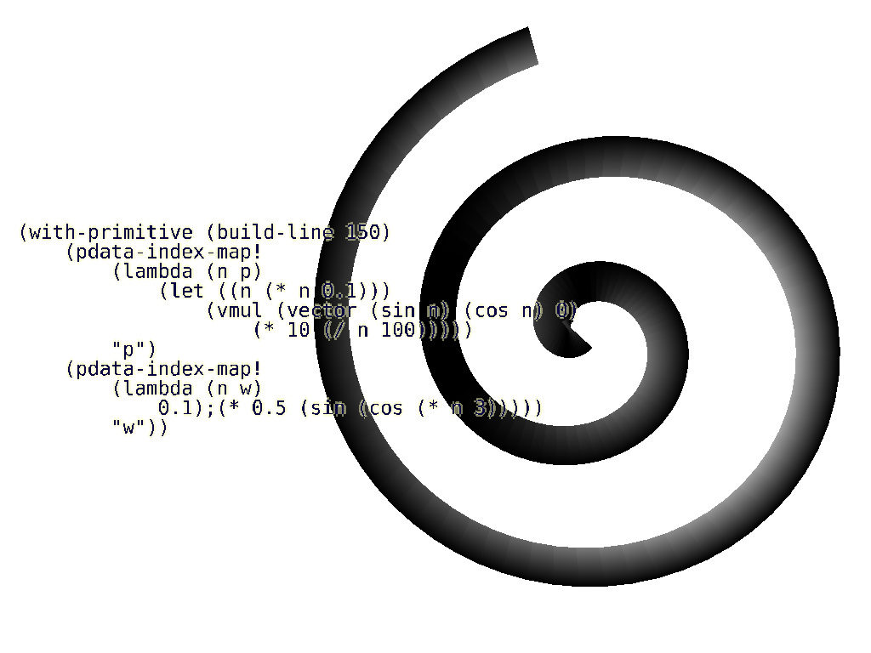
Design by committee
A recognised problem with software is that it is difficult to scale up development. Brookes Law [15] states that “adding manpower to a software project that is behind schedule will delay it further”. With added people, there is a danger of losing the direction made possible by one or a small number of dedicated developers with a clear vision. Successful software projects are often those which are headed by individuals with a very clear philosophy, such an individual is often termed the “benevolent dictator” (Linus Torvalds being the obvious example).

In the case of software containing plenty of ambiguity, too many people can prevent any clear direction. Democratisation or diluting the design process with too many voices is regarded with suspicion by games designers such as Peter Molyneux [16]

Applying free software production to art making
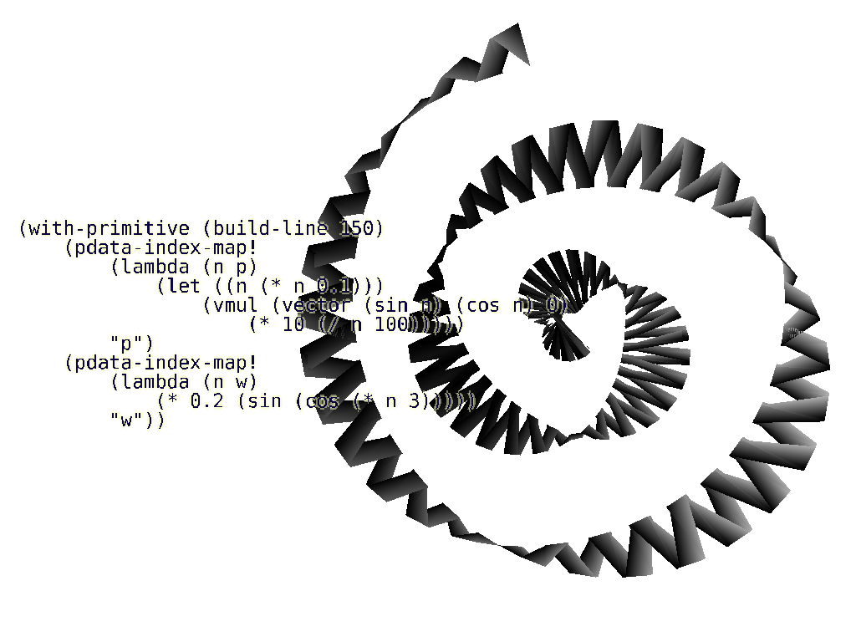
As goals become more ambiguous, the advantages of open source become more difficult to realise. The free software movement has had tremendous success when the goals are clear and easy to convey. Communities can be very large and still work together effectively. When goals become hazy, free software development still works with a clear leading philosophy (usually an individual, or a very small group), but becomes more problematic – as decisions become based more on personal philosophy rather than technical reasons, there is more chance for conflict.

This may explain why there are plenty of quality free software game engines [17-22], where the goals are easy to communicate, but challenging to implement. On the other hand, there is a noticeable lack of free software exhibiting ground-breaking game play. Many computer games available as 'single release' software, along with source code, but are not developed by the free software community. [23-25]

With software art, the single open release model makes most sense. There is much more need to limit development to a few people with a clear understanding of each other, or a individual maker. This is especially true if the intent can only be clearly expressed by the finished article or, much more commonly, if the intent becomes apparent only via the making of the artwork.

When making art in the sphere of a community (software, or any art form), the most important thing is to take an active role in the community by helping to disseminate knowledge – to take part. Releasing your work as free software is a good way to achieve this, giving other people a chance to learn from what you have done. You will benefit indirectly from their increased knowledge, and the strengthening of the community which will result.

Ending thoughts
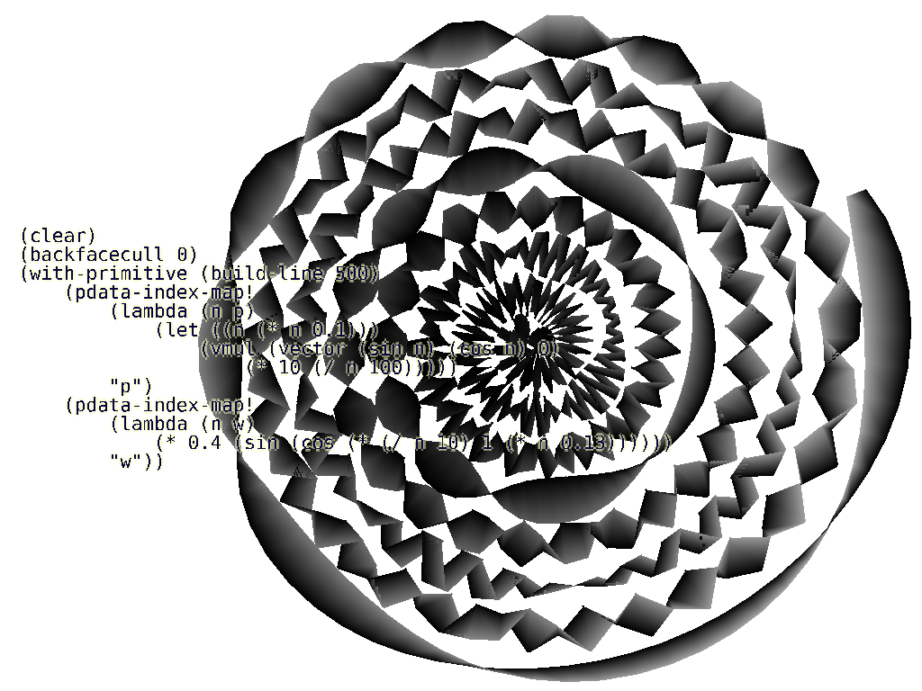
As the goals and intent of a piece of software increases in complexity and ambiguity, the philosophy of the problem space becomes harder to communicate, meaning that larger groups cause problems. When we start to use software to convey some deeper expressions, or the notion of what is fun, an individual perspective is required and the benefits of open sourcing development, or groups in general, are less important.

More thought needs to be given to the playful, personal and fragile forms of software development. Sharing work and peer review is important and needs to be encouraged, but applying software engineering principles to this sort of software making is wrong.

[1] Development on SpiralModular, a software synthesiser, ceased, contributing to the initiative for Om/Ingen which was started on a new codebase.
http://www.pawfal.org/Software/SSM/, http://wiki.drobilla.net/Ingen
[2] Things You Should Never Do, Part I, Joel Spolsky http://www.joelonsoftware.com/articles/fog0000000069.html
[3] Blender http://www.blender.org/
[4] The Mozilla project http://www.mozilla.org/
[5] Supercollider http://www.audiosynth.com/
[6] GIMP http://www.gimp.org/
[7] Fluxus http://www.pawfal.org/fluxus/
[8] Maya http://www.autodesk.com/maya
[9] Pure Data http://crca.ucsd.edu/~msp/software.html
[10] MAX/MSP http://www.cycling74.com/
[11] Houdini http://www.sidefx.com/
[12] RunMe software art repository http://www.runme.org
[13] Processing: A Programming Handbook for Visual Designers and Artists,
Casey Reas, Ben Fry
ISBN 0262182629
[14] TOPLAP http://www.toplap.org
[15] The Mythical Man-Month: Essays on Software Engineering
Frederick P. Brooks
ISBN 0-201-83595-9
[16] Molyneux Talks Fable II, Design Gold http://www.gamasutra.com/php-bin/news_index.php?story=10071
[17] Irrlicht http://irrlicht.sourceforge.net/
[18] PyGame http://www.pygame.org
[19] SDL http://www.libsdl.org
[20] Allegro http://www.talula.demon.co.uk/allegro/
[21] Crystal Space http://www.crystalspace3d.org
[22] Ogre http://www.ogre3d.org
[23] ID Software's Doom ftp://ftp.idsoftware.com/idstuff/source/doomsrc.zip
[24] ID Software's Quake http://www.idsoftware.com/business/techdownloads/
[25] Micropolis http://www.donhopkins.com/home/micropolis/

